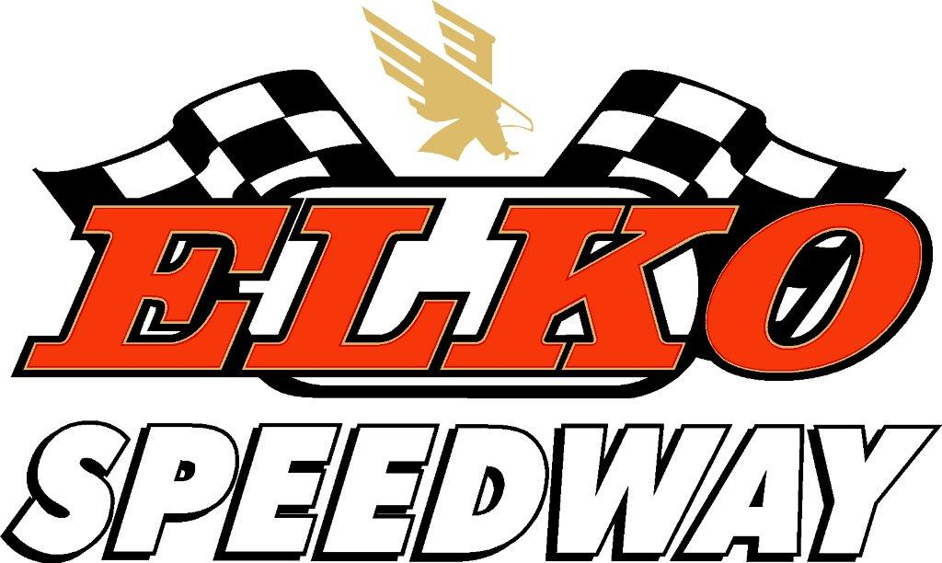 October 5th, 6th
2012 16th Annual Legend Dirt Nationals
OFFICIAL ENTRY
Drivers Name ________________________________ Car # ______ Class Circle one YL SP P M
Hometown _____________________ State ______ INEX # 12- _________ Regional Win? _______________
Phone (Cell) ___________________ AMB TRANSPONDER # ___________________________
(AMB transponders are MANDATORY and available for rent at the track)
Car Entry (doesn’t include pit pass) $75.00 $_______ CREDIT CARD INFO VISA OR MASTERCARD ONLY
(Car entry will increase to $100.00 at the gate) Card # __________________________________
(Pit passes are available on the day of the event for $30/day) Address _________________________________
City/State___________________ ZIP __________
EXP DATE _________ SECURITY CODE __________

Authorized signature __________________________
CHECKS TO BE MADE OUT TO ELKO SPEEDWAY
P.O. BOX 246; 26350 FRANCE AVE, ELKO MN 55020
Office: 952-461-7223 or Fax 952-461-3397 or info@elkospeedway.com
http://www.elkospeedway.com/

PRENTRY FEE


Comfort Inn & Suites
17605 Kenrick Ave., Lakeville, MN 55044
952-898-3700 www.comfortsuites.com
Mention Elko Speedway and get 15% off your room rate

SPEC FUEL WILL BE ANNOUNCED LATER

SPEC GAS WILL BE TRACK FUEL - 91 octane
